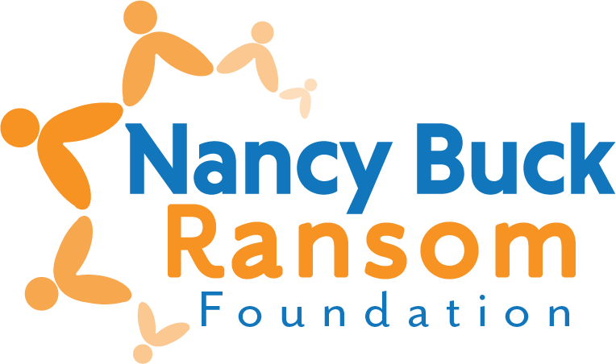

**Interim Grant Evaluation**

*Revised December 2023*

For Multi-year Grants Only

1. **ORGANIZATION AND PROGRAM/PROJECT INFORMATION**

1. Organization name:

2. Contact for this evaluation:

Name:

Title:

E-mail:

1. **EVALUATION – *Do not exceed one page***
2. What activities did you conduct?
3. Please note any significant changes or challenges in your organization during the grant period – governance, structure, focus, etc.
4. **EXPENDITURES**
5. Please attach your Profit and Loss statement for the most recent completed fiscal year.
6. **SUBMIT YOUR EVALUATION**

Interim evaluations are due no later than one year following the date the funds were disbursed to you and are required to receive the next year’s disbursement.

**We prefer to receive the evaluation via email as one pdf for the report.**

Completed form and additional documents may be:

Mailed to Nancy Buck Ransom Foundation

PO Box 749, Monterey, CA, 93942

<or> Emailed to [grants@nbrfoundation.org](mailto:grants@nbrfoundation.org?subject=Grant%20Evaluation)

* *Emails should not be over 10Mb*
* *You’ll receive an auto-reply email when received*

Questions? Lynn Bentaleb, (831) 375-3311, or [lynn@nbrfoundation.org](mailto:lynn@nbrfoundation.org)