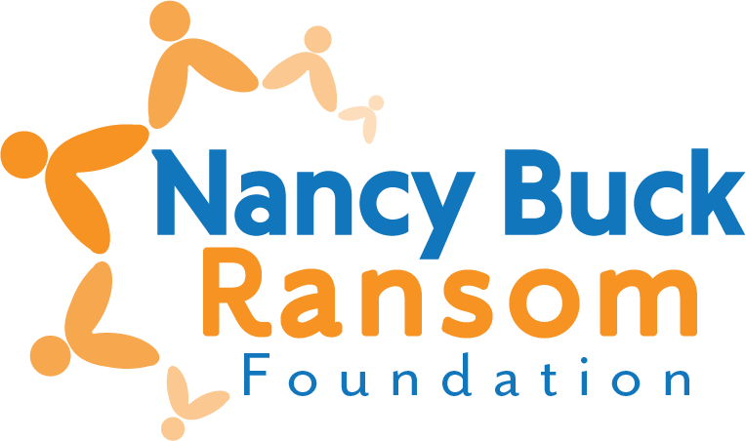

**Final Grant Evaluation**

*Revised December 2024*

Please complete the following form and attach the requested documents.

1. **ORGANIZATION AND PROGRAM/PROJECT INFORMATION**

1. Organization name:

2. Contact for this evaluation:

Name:

Title:

Daytime telephone:

E-mail:

3. Amount received:

1. **EVALUATION – *Do not exceed two pages***
2. What activities did you conduct?

1. What changes are you seeing as a result of your work, and how were they measured? **What were the results?**
2. How will your results inform your future activities? Will you make changes to your programs based on these results and client feedback?
3. Please note any significant changes in your organization during the grant period – governance, structure, focus, etc.
4. **EXPENDITURES**
5. Please attach your Profit and Loss statement for the most recent completed fiscal year.
6. **SUBMIT YOUR EVALUATION**

Evaluations are due no later than one year following the date the funds were disbursed to you, OR before you apply again, whichever is sooner.

**We prefer to receive the evaluation via email as one pdf for the report.**

Completed form and additional documents may be:

Mailed to Nancy Buck Ransom Foundation

PO Box 749, Monterey, CA, 93942

<or> Emailed to [grants@nbrfoundation.org](mailto:grants@nbrfoundation.org?subject=Grant%20Evaluation)

* *Emails should not be over 10Mb*

Questions? Lynn Bentaleb, (831) 375-3311, or [lynn@nbrfoundation.org](mailto:lynn@nbrfoundation.org)