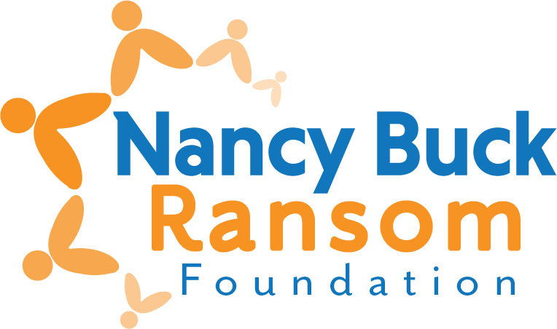

Final Grant Evaluation
Revised December 2025
Please complete the following form and attach the requested documents.

- ORGANIZATION AND PROGRAM/PROJECT INFORMATION
1. Organization name:
2. Contact for this evaluation:
Name:
Title:
Daytime telephone:
E-mail:
3. Amount received:

- EVALUATION – Do not exceed two pages
- What activities did you conduct?

- What changes are you seeing as a result of your work, and how were they measured? What were the results?

- How will your results inform your future activities? Will you make changes to your programs based on these results and client feedback?

- Please note any significant changes in your organization during the grant period – governance, structure, focus, etc.

- EXPENDITURES

- Please attach your Profit and Loss statement for the most recent completed fiscal year. If you’re submitting the evaluation and the application at the same time, only one Profit and Loss statement is required.

- SUBMIT YOUR EVALUATION
Evaluations are due no later than one year following the date the funds were disbursed to you, OR before you apply again, whichever is sooner.
We prefer to receive the evaluation via email as one pdf for the report.
Completed form and additional documents may be:
Mailed to Nancy Buck Ransom Foundation
PO Box 749, Monterey, CA, 93942

<or> Emailed to grants@nbrfoundation.org
- Emails should not be over 10Mb
- You’ll get an auto-reply message to know it was received
Questions? Lynn Bentaleb, (831) 288-2028, or lynn@nbrfoundation.org

