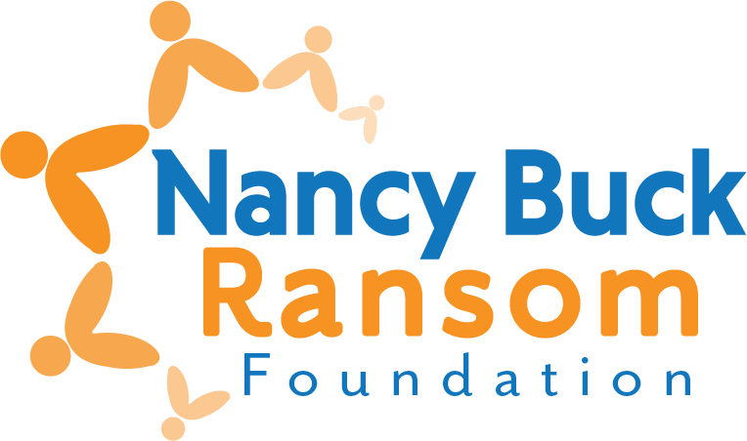

Interim Grant Evaluation
Revised December 2025
For Multi-year Grants Only
- ORGANIZATION AND PROGRAM/PROJECT INFORMATION

- Organization name:

- Contact for this evaluation:
Name:
Title:
E-mail:

- What is the demographic composition of your board? Please report percentages including gender identity, race and ethnicity.

- What is the demographic composition of your senior staff (exempt employees)? Please report percentages including gender identity, race and ethnicity.

- EVALUATION – Do not exceed one page

- What activities did you conduct?

- Please note any significant changes or challenges in your organization during the grant period – governance, structure, focus, etc.
- EXPENDITURES

- Please attach your Profit and Loss statement for the most recent completed fiscal year.

- SUBMIT YOUR EVALUATION
Interim evaluations are due no later than one year following the date the funds were disbursed to you and are required to receive the next year’s disbursement.
We prefer to receive the evaluation via email as one pdf for the report.
Email to grants@nbrfoundation.org
- Emails should not be over 10Mb
- You’ll receive an auto-reply email when received
Questions? Lynn Bentaleb, (831) 288-2028, or lynn@nbrfoundation.org

